**School of Health and Social Care**

Riverside College is highly popular and successful Further Education college located in Widnes. It is situated at the hub of the Mersey Gateway, within easy reach of Liverpool, Manchester and Chester. We currently cater for over 3,600 16-18 students, over 2,000 adults, 350 Higher Education Students and over 500 Apprentices. We also won Employer of the Year at the Halton Business Awards in June 2025.

Following an Ofsted inspection in April 2024, the College has been given the highest possible rating of **OUTSTANDING** by Ofsted for a second time. After a meticulous review of the College, inspectors made the following judgements:

|  |  |
| --- | --- |
| **OVERALL EFFECTIVENESS** | **OUTSTANDING** |
| The quality of education | **Outstanding** |
| Behaviour and attitudes | **Outstanding** |
| Personal development | **Outstanding** |
| Leadership and management | **Outstanding** |
| Education programmes for young people | **Outstanding** |
| Provision for learners with high needs | **Good** |
| Adult learning programmes | **Outstanding** |
| Apprenticeships | **Outstanding** |



**What is it like to work at Riverside College?**

Inspectors said:

"Senior leaders and managers have a very clear rationale for their aspirational curriculums. “

“Leaders carefully consider the courses they provide for students, apprentices and those who have high needs.”

“They have a strong sense of community and are passionate to provide life-changing opportunities for young people and adults, many from disadvantaged backgrounds, to achieve their personal and career goals."

"Staff feel appreciated for the contribution they make to the college."

“Students and apprentices enjoy their learning at Riverside. They display extremely positive attitudes and would recommend the college to friends, family and peers.”

The Health and Social Care Department offer an exciting curriculum and have strong employer engagement. This provides the opportunity to understand the requirements of the sector and prepares students for work placement.

The School of Health and Social Care offers the following programmes:

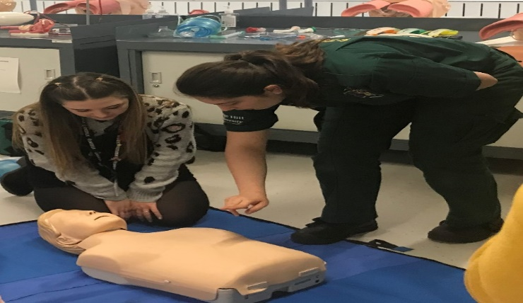

* Apprenticeships at all levels
* Health and Social Care Level 1
* Health and Social Care Level 2 NQF
* Health and Social Care Level 3 Extended Diploma

(Health and Social Care Pathway)

* Health and Social Care Level 3 Extended Diploma

(Health Studies Pathway)

* Counselling Level 2 & 3
* Counselling Foundation Degree
* T Level Health
* Various Health related short courses

Riverside College is committed to:

* Providing learning experiences of outstanding quality
* Investing in teaching, learning and assessment
* Offering students distinctive and valuable opportunities to develop personally and professionally and academically
* Supporting every individual student to reach their full potential

Over recent years, significant investments have been made in teaching and learning and support for students at Riverside College, which we believe are key to our success.

**Outstanding Results 2025:**

99.6% A Level Pass Rate

99% Level 3 Pass Rate

100% in 29 A Levels

100% in 20 Vocational Subjects (including BTEC and UAL)

Over 95% High Graders in Animal Management and Engineering

If you would like further information or an informal discussion about the role, please contact Joanne Burton, Head of School for Health and Social Care and Childcare on 0151 257 2800.

